**MGM COLLEGE**

(AFFILIATED TO MAGADH UNIVERSITY, BODH GAYA)



A

PROJECT REPORT

ON

**Library Management System**

OF

BACHELOR IN COMPUTER APPLICATION

SESSION:-2016-2019

|  |  |
| --- | --- |
| **ROLL NO.** | **NAME OF MEMBERS** |
| 12 | Abhishek Kumar |
| 21 | Durgesh Kumar |
| 60 | Gaurav kumar |

**MENTOR’S NAME: Vikash Kumar**

**INTRODUCTION OF PROJECT**

Library management system is a project which aims in developing a computerized system to maintain all the daily work of library. This project has many features which are generally not available in normal library management systems like facility of user login. It also has a facility of admin login through which the admin can monitor the whole system. It has also a facility where logging in their accounts can see list of books issued and its issue date and return date and also the add student add book details and delete and update books record and student record can request the librarian to add new books by filling the book request form. The librarian after logging into his account i.e. admin account can generate various reports such as student report, issue report, teacher report and book report

Overall this project of ours is being developed to help the students as well as staff of library to maintain the library in the best way possible and also reduce the human efforts

**OBJECTIVE OF PROJECT**

The project objectives that will be achieved after completion of the project are discussed in this subchapter. The objectives are as follows:

* Request column for librarian for providing new books.
* Easily any book and student record delete or update through librarian.
* Student login page where student can find books issued by him/her and date of return.
* A search column to search availability of books.
* Login page where teacher can add any events being organized in the college and important suggestions regarding books.
* Less human efforts.
* Easy to use.
* Find out the Student and book details easily.

**Scope of the Project**

* Proposed system will have a facility.
* Proposed system after logging in to their accounts student can request books as well as provide suggestions to improve library.

**Scope system provides with following solutions:**

* It provides “better and efficient” service to members.
* Faster retrieval of information about the desired book.
* Provide facility for proper monitoring reduce paper work and provide data security.
* All details will be available on a click.

**Modules used in Project**

* Login
* Register
* Forgot Password
* New Student Add
* New Book Add
* Student Details
* Book Issue
* Return Book
* Book Details
* Update and Delete Student Details
* Update and Delete Book Details
* Statistics
* About
* Searching student name through Student Id
* Searching Book name through Book Id

**LANGUAGE AND TOOLS TO BE USED**

* **Java**
* **NetBeans**

**HARDWARE AND SOFTWARE CONFIGURATION**

**Hardware Requirement**

Processor  **:** Intel core Duo, 2.0GHz or more

RAM  **:** 1 GB or more

HARDDISK **:** 250 GB or more

Monitor **:** 17”CRT, or LCD monitor

**Software Requirement**

IDE  **:** Net Beans version 8.0.1

Front End **:** Swing

BACK End **:** SQL Server Lite

Operating system **:** Windows , Linux or Unix

**Waterfall Model**

Waterfall Model is used for developing program. It is mostly used now a day to create new programs by most program developing companies. It has many steps which will come one after another, we will discuss it below;

1. Planning
2. Requirements
3. Feasibility Study
4. Analysis
5. Design
6. Testing
7. Implementation & Maintenance

**I. Planning**

Most important part to design any project is to make a flawless planning before start a project. Most important thing in planning is that project should complete on time.

To do this we are using some tools to make a flawless planning. These tools are known as;

**I.I Software Development Life Cycle**

It stands for System Development Life Cycle. The Systems development life cycle(SDLC),also referred to as the application development life cycle, is a term used in system engineering, information system and software engineering to describe a process for planning, creating, testing and deploying an information system. The systems development life cycle concept applies to range of hardware and software configurations, as a system can be composed of hardware only, software only, or a combination of both. There are usually six stages in this cycle: analysis, design, development and testing, implementation, documentation and evaluation.

**ANALYSE**

**DESIGN**

**Testing**

**IMPLENTATIN**

**MAINTENANCE**

**II.Requirement**

Requirement is a processor for asking client what he is actually need, In our scenario Mgm College need a computer software which will help management as well as students to do their work property and with ease of access. Now we Know Mgm College library need a comprehensive software which covers all its necessities by default and further no need of any additional software for this.

**lII.** **Feasibility Study**

Feasibility study is very important aspect for any proposed model. It gives us direction to implement or not to implement the further proposed project

This study is carried out with the help of literature, primary data, current market prices and logical thoughts

There are four types of feasibilities expressed by Jennifer Campbell (2007) which are discussed in this chapter with relevant data. The economic feasibility, technical feasibility, operational feasibility.

1. **Economic Feasibility:**

In this type of feasibility, the cost of hardware, software and overall budget is evaluated to run the new system. Tangible and intangible benefits are also considered in the evaluation.

1. **Technical Feasibility:**

In this type of feasibility, the present hardware and software compatibility with the new one is checked out to run the new system.

1. **operational Feasibility:**

In this type of feasibility, the issues like, operational scope

**III.Analysis**

Now we will analyse what is required for Mgm college library, a few thing after we can start designing the software, these things are;

It contains graphic user interface, so user can easily understand its functionality.

There should be provide specific code numbers to books so it is easy to remember the book type.

There should be provided special code numbers to teachers and students so easy to handle work load.

**IV. Design**

In this phase we will design what is necessary for creating a program and after analysing requirement of Mgm college, we will do accordingly. We will create a software with the help of vb.net so everything will be all right and making no troubles.

**V. Testing**

At this phase we test the software and give to client to use it, so if there is any query and requirement we will add and fix at this phase.

**VI. Implementation**

In this phase, we will do implement our software to check it is working good or not and it is fulfill all requirement or not, if any problem coming in this phase, we will rectify and fix that problem.

**VII. Maintenance:-**This phase is coming after completing and testing, it is necessary to maintain the software monthly or quarterly, so if any problem coming at that time we can rectify and fix that problem.

**Entity Relationship Diagram**

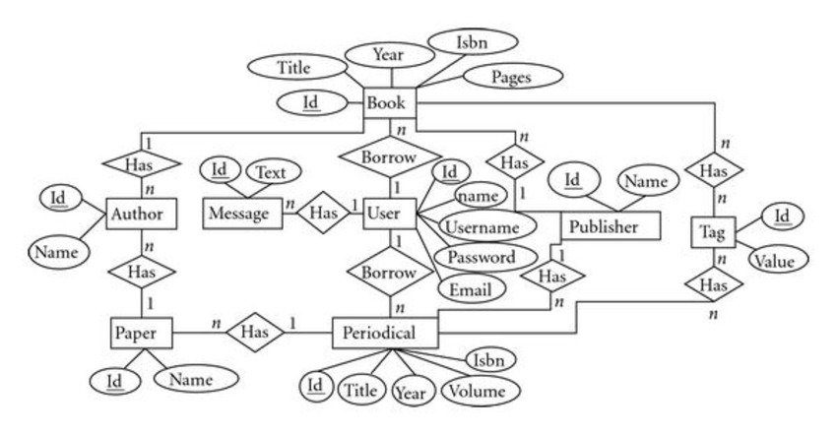

**Data Flow diagram**

**Level 0 DFD- Library Management System**

**Book Issue**

**Login**

**Register**

**Forgot Password**

**New Student**

**Student Details**

**New Book**

**Return Book**

**Book detail**

**Statistics**

**Searching Book**

**Searching Student**

**Data Table & Date Base Coading: -**

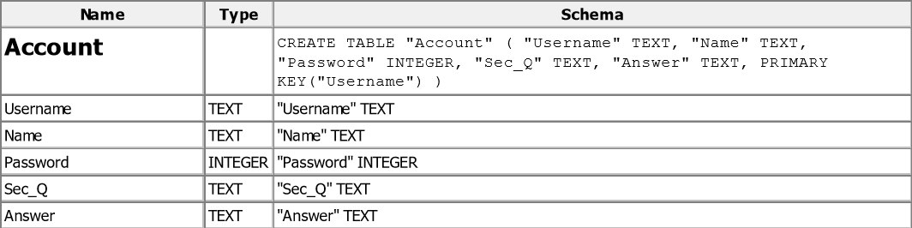

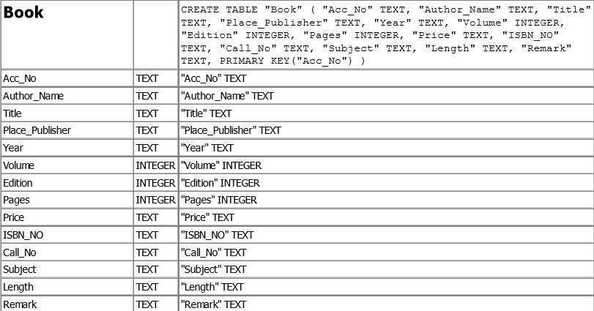

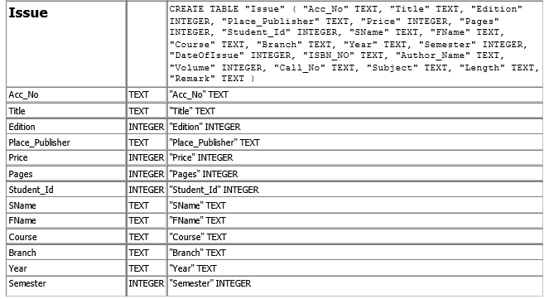

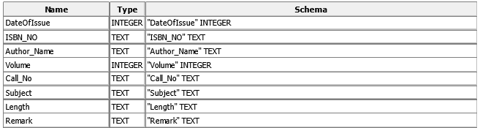

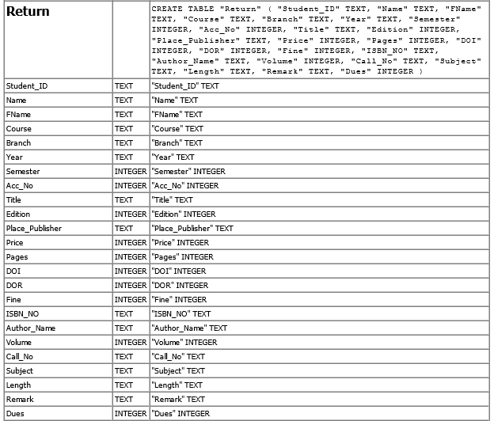

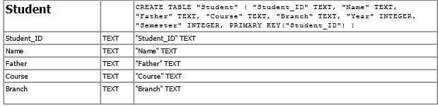

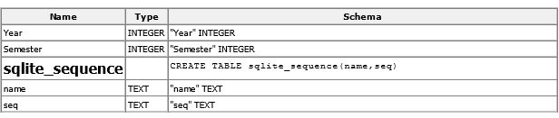

**Form (Screen Short): -**

**Available Book**

Available for different type of the book and other writers. The book for any edition.

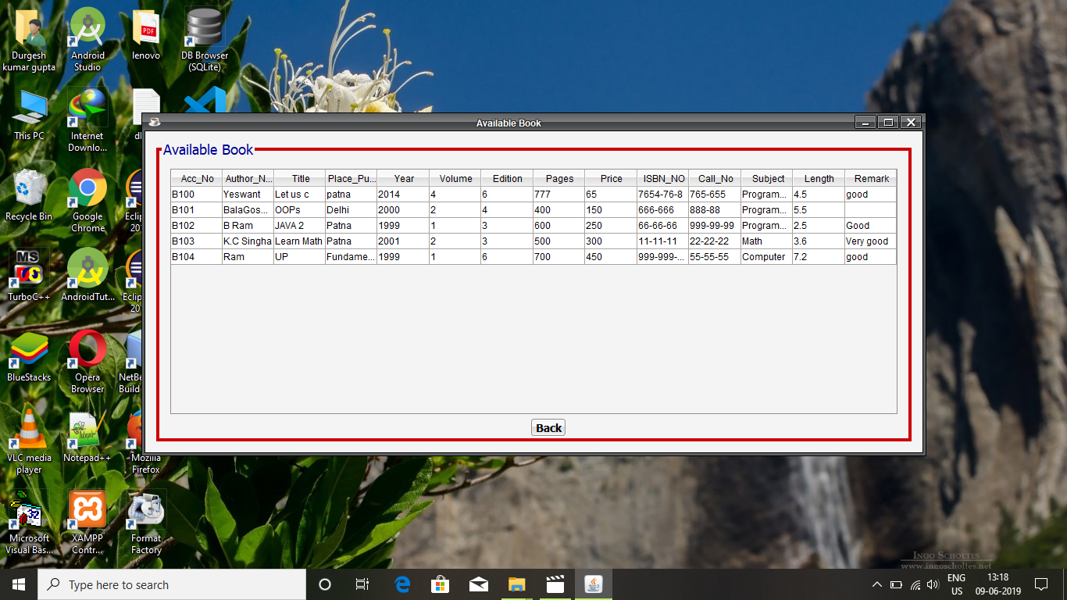

**Book Update**

The book was update the Edition, Volume, Year, Publisher/Place, Price etc.

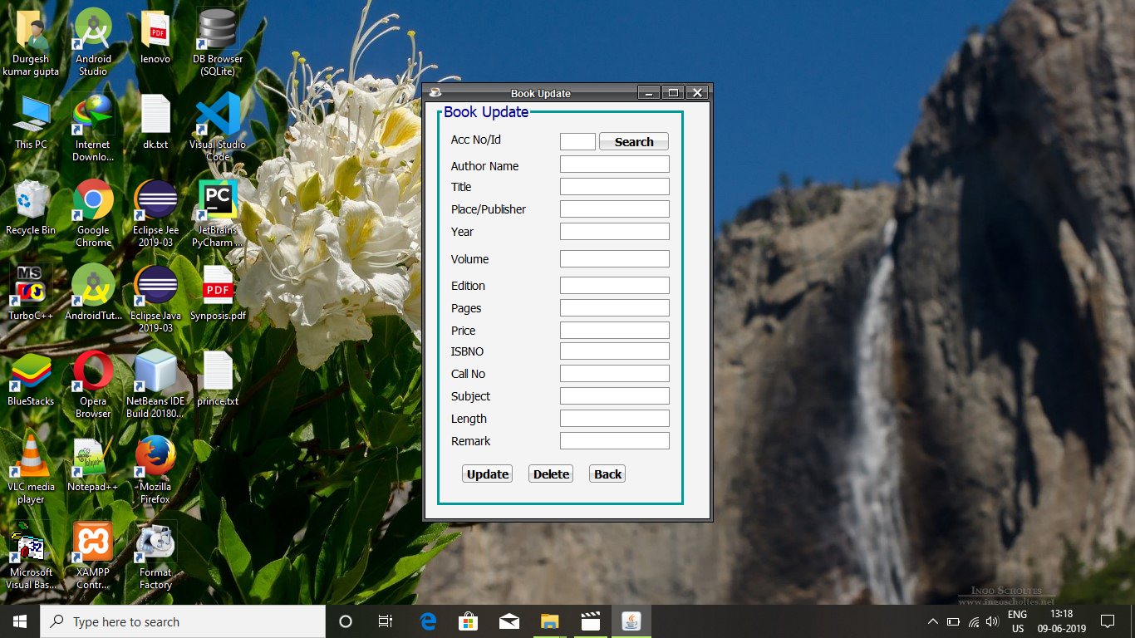

**Forgot Password**

The Forgot password in user account.

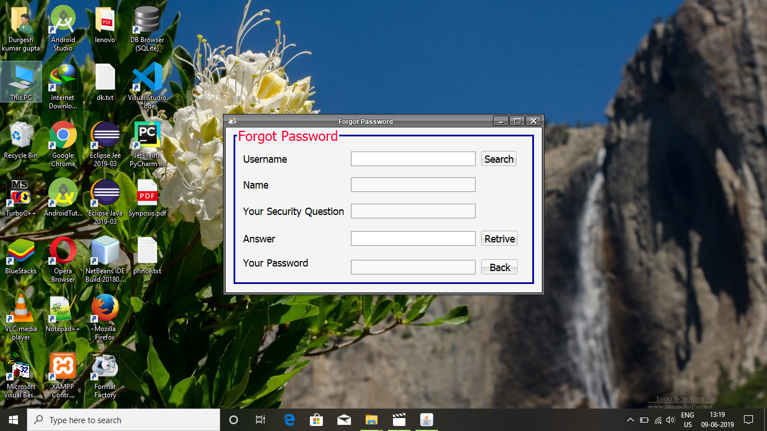

**Home Page**

The library management system is home page.

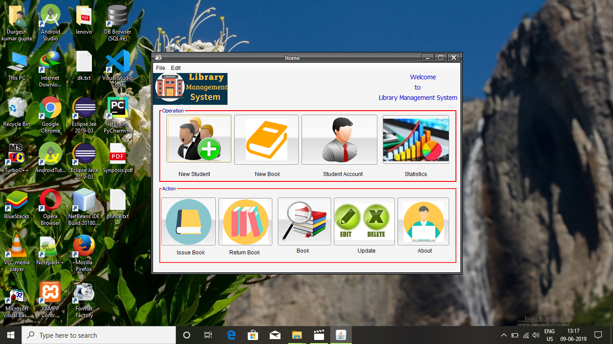

**Issue Book**

The student issue for book in library**.**

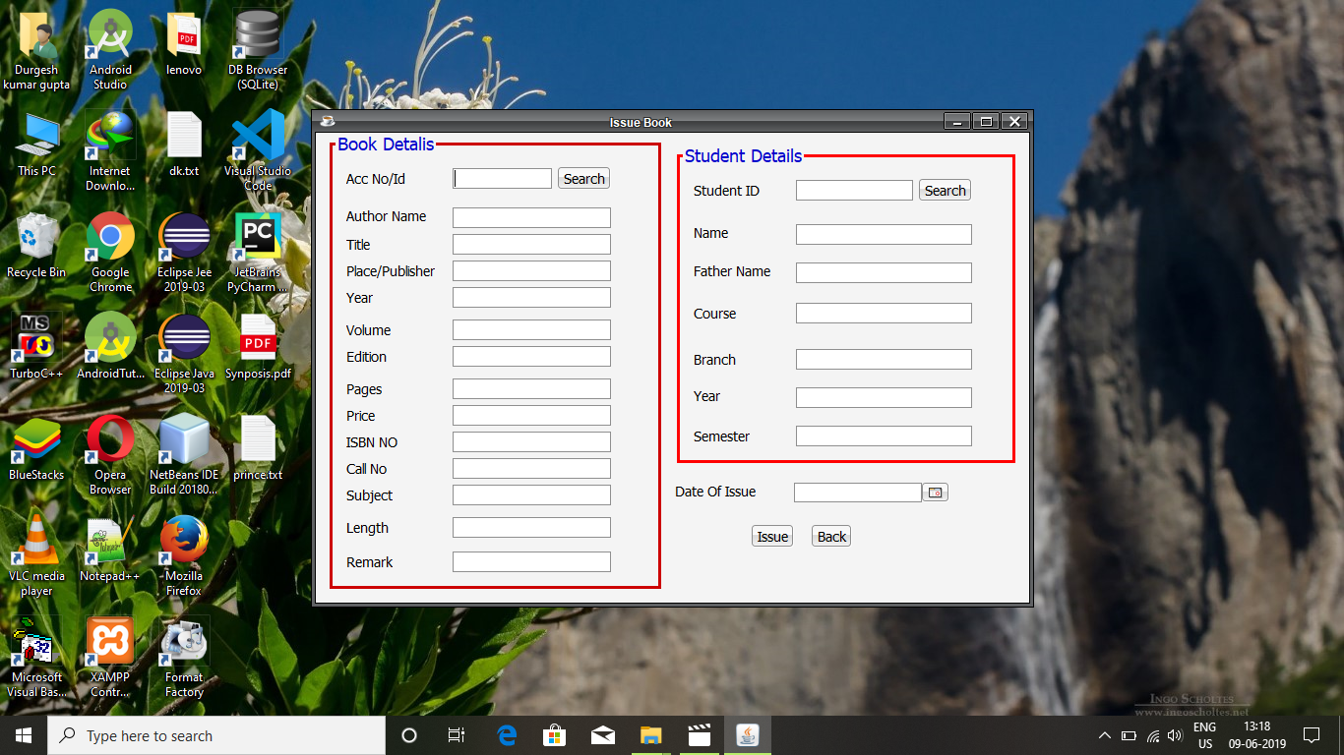

**Loading**

The library management system is loading to open the project.

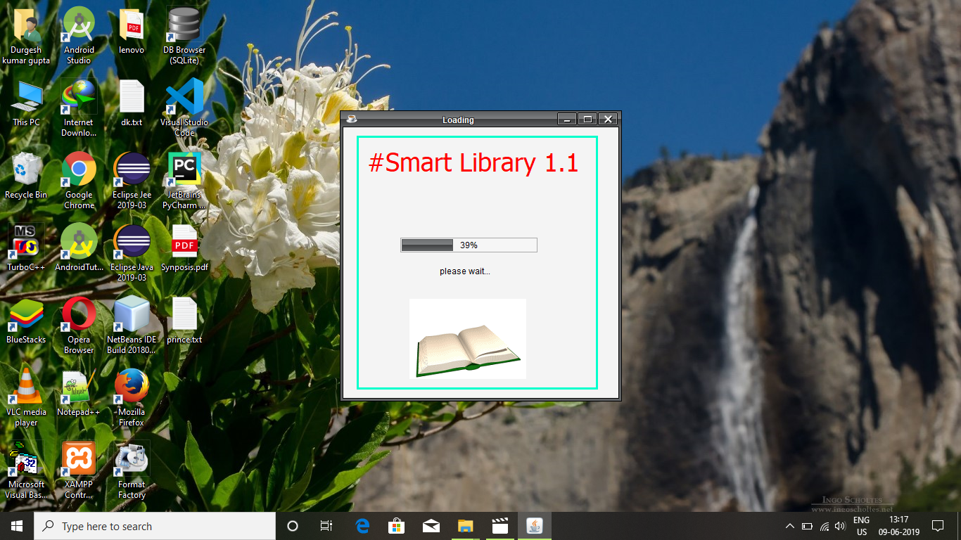

**Login**

The user for login the library management system

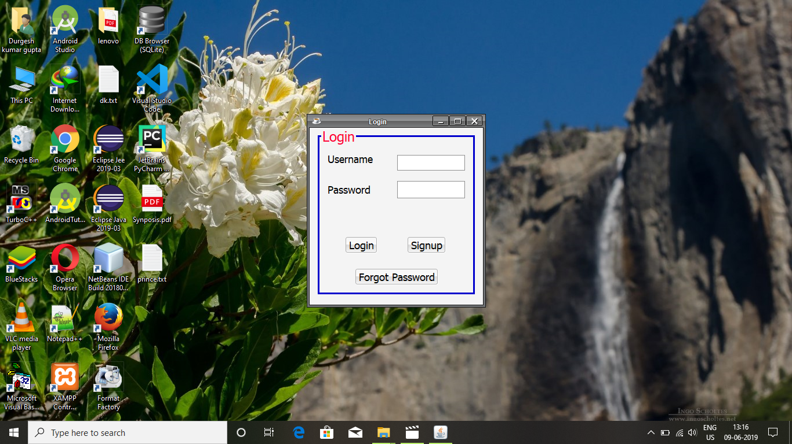

**New Account**

The new user for create the new Account

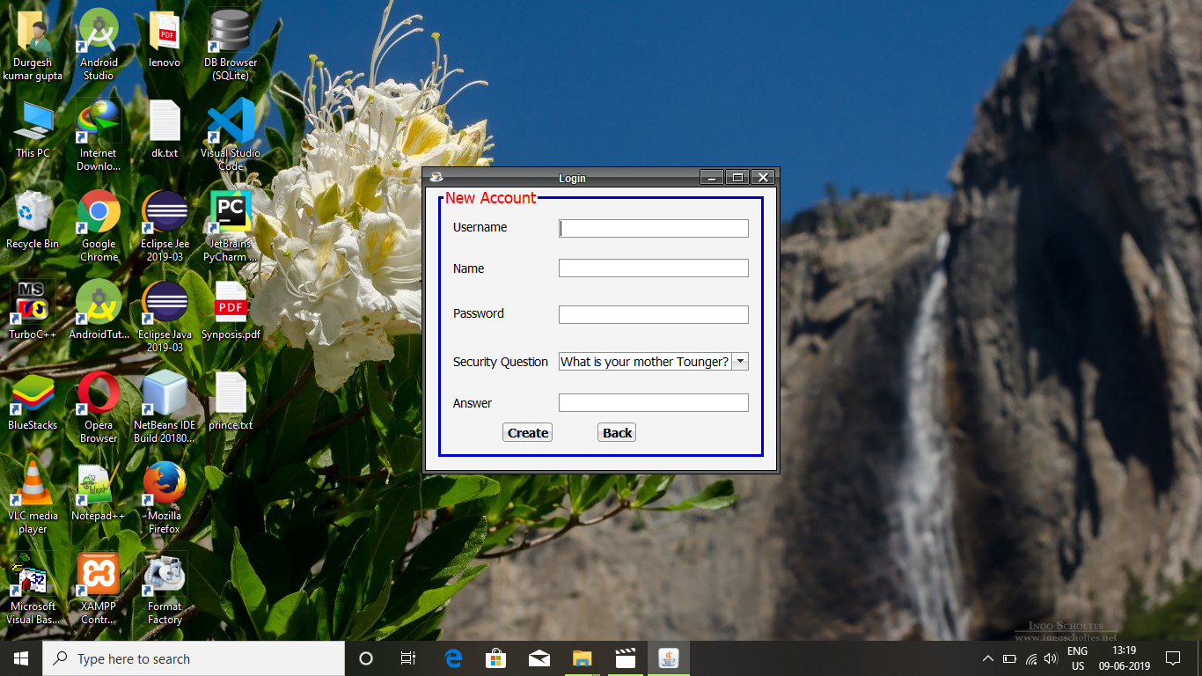

**New Book**

The new book is adding to library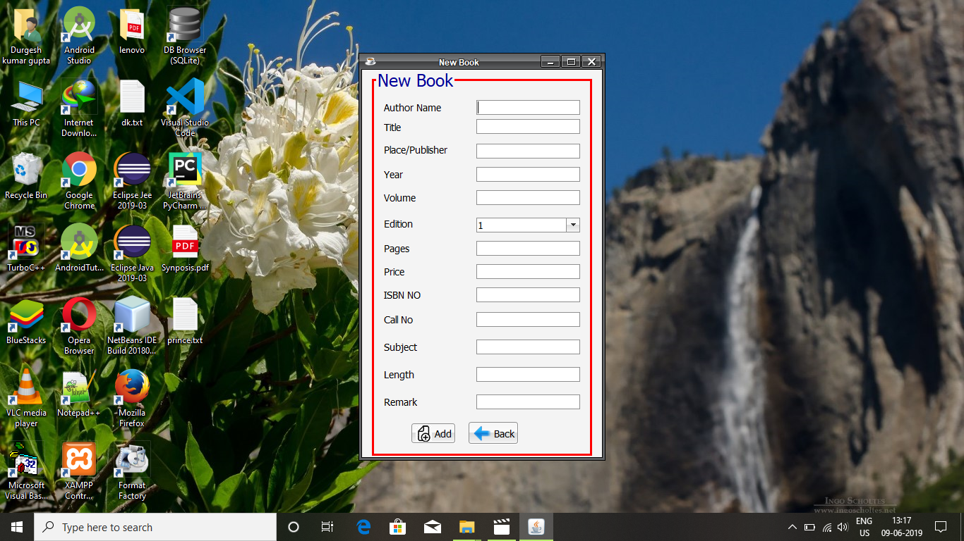

**New Student**

The new student is adding to library

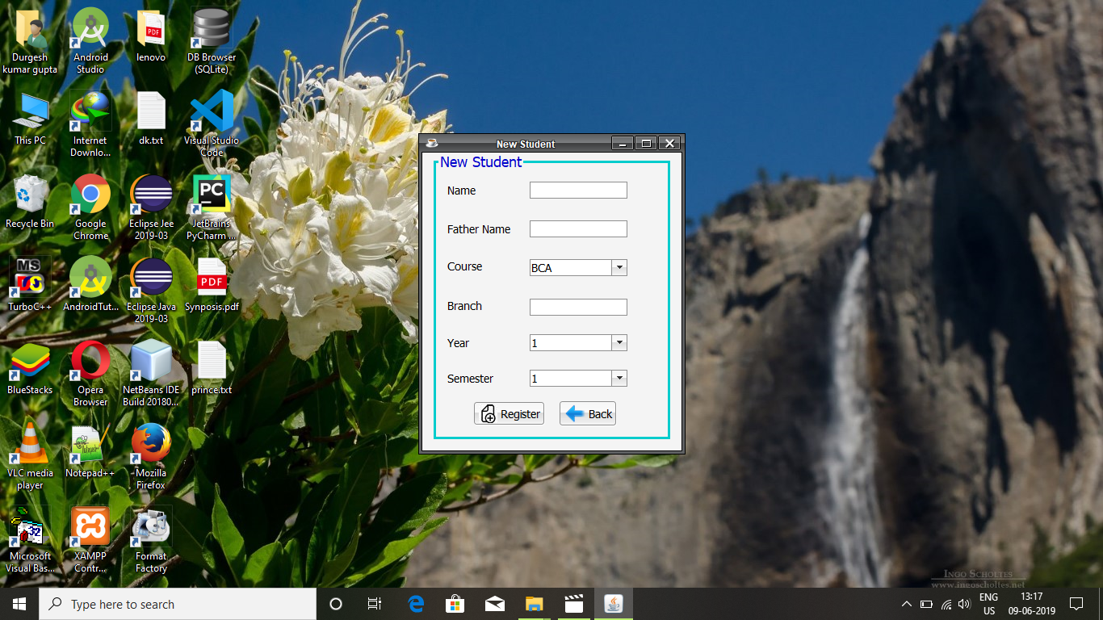

**Return Book**

The student is return the book in library.

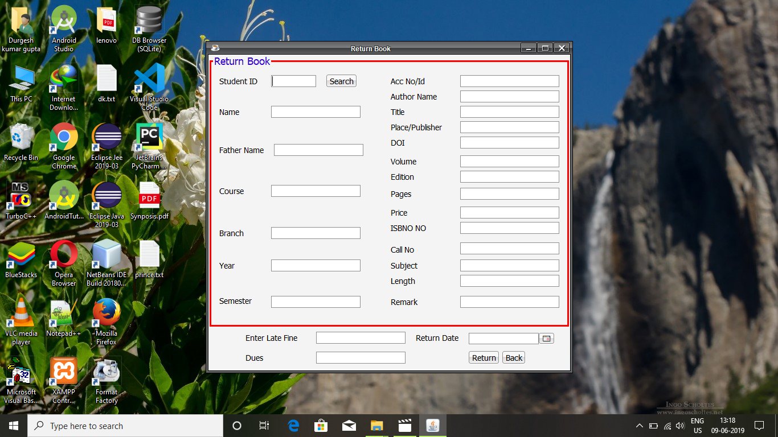

**Statistics**

It show all Issue and Return details.

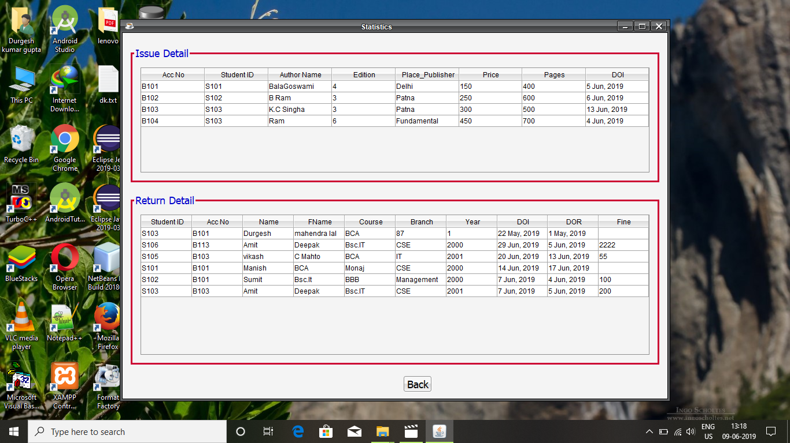

**Student Account**

It shows Student Details**.**

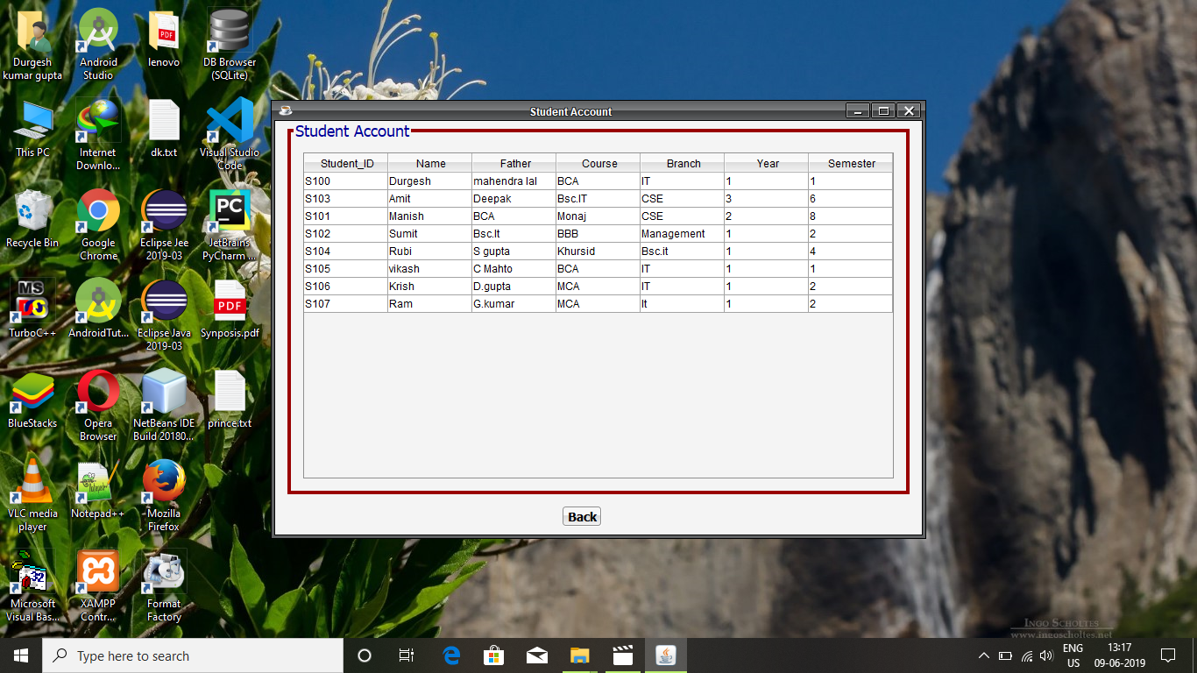

**Student Update**

It is shows Student Update.

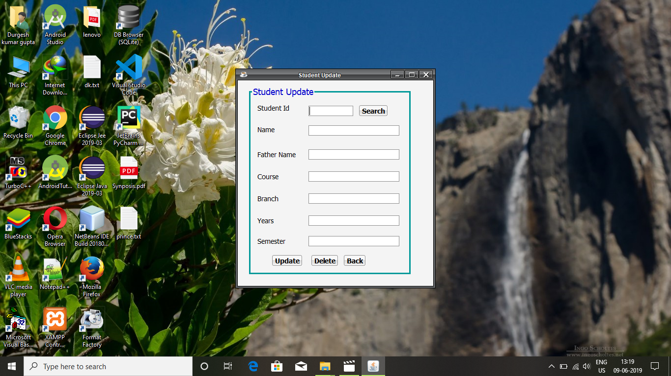

**Update**

It shows update Book and Student.

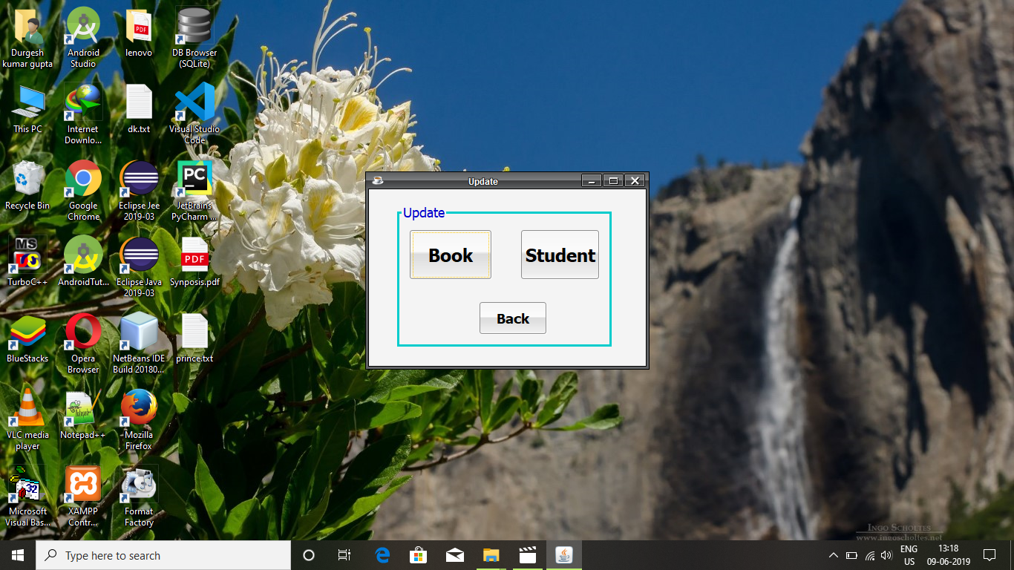

**Report**

**Understandably:** A method is understandable if someone other the creator of the method can understand the code (as well as the creator after a time lapse). We use the method, which small and coherent helps to accomplish this.

**Cost-effectiveness:** Its cost is under the budget and make within given time period. It is desirable to aim for a system with a maximum cost subject to the condition that it must satisfy the entire requirement.

Scope of this document is to put down the requirement, clearly identifying the information needed by the user, the source of information and outputs expected from the system.

**Limitation of project**

* System is intended for a single computer.
* System is not for online.
* System cannot delete records.
* Also apart from Books no new category can be added in the system (or in turn be issued) like CDs etc.
* Doesn’t provide online services for any users.

**Feature of Project**

**The key features of library management system are:-**

* Add books
* Return books
* Issue books
* Update Student and Book Account Details
* View record of books issued
* Password for administrator to use the system
* Books are categorized into different departments
* Library members (staff & others)

**Bibliography: -**

* **stack overflow**
* **Javatpoint**
* **geeksforgeeks**